Chapter 11, Solution 15.

To find 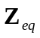, insert a 1-A current source at the load terminals as shown in Fig. (a).
1 A
j 
2 V_{o}
-j 
1 
1
2
+
V_{o}
−
(a)

At node 1,
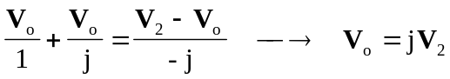 (1)
At node 2,
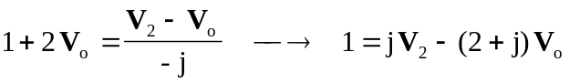 (2)
Substituting (1) into (2),
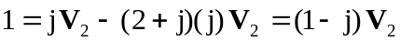
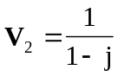
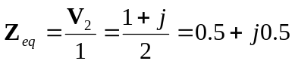
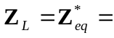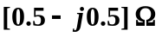

We now obtain 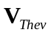 from Fig. (b).
j 
2 V_{o}
-j 
1 
+
V_{o}
−
(b)
120 V
+
−
+
V_{Thev}
−



 

